DIGITALISATION-DRIVEN PROACTIVE PORTFOLIO MANAGEMENT IN NATIONAL TRANSPORTATION PROJECTS
Fatih Kaya
Asst. Program Manager, EMAY International Eng. and Cons. Inc., fatih.kaya@emay.com
A. Sinan Alemdar
Deputy General Manager, EMAY International Eng. and Cons. Inc., salemdar@emay.com

ABSTRACT
Digitalising the construction industry presents unique challenges, including fragmentation, hindering the adoption of digital tools. Among the various sectors within the industry, transportation and infrastructure investments stand out as crucial areas that require efficient management of changes. Specifically, these challenges are particularly pronounced within the national transportation sector, encompassing highways, railways, and urban transportation. The fragmentation within these sub-sectors poses a significant obstacle to the digitalisation process. This paper addresses the difficulties encountered in the digitalisation process and explores the distinct characteristics of each sub-sector that necessitate tailored approaches to project management. This paper develops a portfolio management approach that can overcome the challenges posed by fragmentation and enable seamless digitalisation within the Ministry by creating a web-based project management tool called Transportation Management System (TMS) to ensure effective coordination and oversight.
The TMS facilitates the monitoring and performance evaluation of construction projects by the relevant institutions within the Ministry. By re-evaluating traditional project management processes and redesigning fragmented structures, the TMS offers a centralised platform for collaboration, bridging the gaps created by fragmentation. The TMS incorporates a work breakdown structure that caters to the specific requirements of the Ministry and ensures a standardised approach across all projects. This structure enables linear tracking of transportation projects, encompassing construction work schedules, cash flows, and monitoring physical and monetary progress. Integrating project contracts and geographic information systems (GIS) allows comprehensive project tracking and analysis.
Furthermore, the TMS utilises earned value analysis to assess project performance and measure the impact of changes. This data-driven approach enhances proactive project management, identifying issues such as time extensions and cost overruns. It enables the implementation of appropriate measures and supports proactive decision-making. This research contributes to understanding how digitalisation can revolutionise the construction industry, particularly in the transportation sector. Integrating various sub-sectors under a unified management framework strengthens project management practices and fosters collaboration. The findings underscore the importance of embracing digital tools and a comprehensive portfolio management approach to drive effective change management in the construction industry.
Keywords: Digitalization, Portfolio Management, Earned Value Analysis, Transportation Management System (TMS), Change Management

INTRODUCTION
In an era marked by the relentless march of digitalisation across various sectors, the construction industry is no exception to this sweeping tide of transformation. Industries, including construction, are compelled to adapt as the world becomes increasingly interconnected and data-driven (McKinsey&Company, 2020; Winfield, 2020). However, the construction landscape poses unique challenges to digitalisation, characterised by complexities arising from the lack of replication, transience, and fragmentation (Parusheva, 2019).
The digitalisation of the construction industry is a highly promising development that presents many benefits. By integrating digital solutions, actors in the construction sector can achieve greater efficiency, streamlined processes, and improved project outcomes. However, several obstacles must be overcome to realise these benefits fully.
One of the key challenges in the construction industry is the replication of non-standardized processes across projects. This can impede the seamless implementation of digital solutions, as different projects may require different approaches (Koeleman et al., 2019). Another challenge is the temporal nature of construction activity, which can present difficulties in maintaining continuity. This can result in delays, miscommunications, and errors that can negatively impact project outcomes.
Furthermore, the fragmentation of the construction industry presents further complications in integrating digital technology. With a diverse range of stakeholders involved, including architects, engineers, contractors, and sub-contractors, ensuring everyone is on the same page can be a challenge. Even among employers in the road and railway sectors, considered under the transport sector of construction at the upper scale, siloed and separate structures can be seen. This can lead to delays, misunderstandings, and even disputes that can derail projects.
Despite these challenges, implementing digital solutions in the construction sector, particularly transportation, is becoming increasingly necessary (Berger, 2016). The advent of intelligent transportation systems, the Internet of Things (IoT), and autonomous vehicles all require a robust digital foundation. These technologies enhance operational efficiencies and pave the way for safer, more sustainable transportation networks (Easton, 2022). Building Information Modeling (BIM) is on the rise, offering streamlining of design, collaboration, and project management (Mallela & Bhargava, 2021). At the heart of this digital transformation is the need for a comprehensive and integrated data ecosystem to facilitate collaboration, communication, and data sharing between all stakeholders (Pappas et al., 2018). The capacity to collect, analyse, and leverage data from various phases of transportation projects from inception to completion holds immense potential. Only by successfully overcoming these challenges can the construction sector genuinely reap the benefits of the digital age.
Addressing the challenges of digitalisation, establishing a robust portfolio management system within the Turkish Ministry of Transport and Infrastructure (Ministry) emerges as an exemplar of navigating these complexities, harnessing the potential benefits of digitalisation while accommodating the unique demands of the construction landscape, particularly in transportation. The Transportation Management System (TMS) represents a highly efficient and streamlined approach to asset management, budget allocation tracking, and project progress monitoring. It is an invaluable digital portfolio management tool for transportation construction projects. This paper will delve into the various methodologies employed by TMS and thoroughly explore the multitude of significant outcomes that it can deliver for the Ministry.

THE TRANSPORTATION MANAGEMENT SYSTEM (TMS)

Methodology
The methodology for developing the TMS encompassed a series of structured steps. Beginning with data collection, information was gathered from diverse Ministry institutions through progress monitoring formats and on-site interviews. Subsequently, standardisation was pursued, establishing a uniform Work Breakdown Structure (WBS) and project management procedures. The software development phase involved designing and deploying a three-tier architecture, ensuring secure data integration and management. Performance analysis was conducted through earned value analysis, employing CPI and SPI metrics on a regional basis to anticipate project deviations. The final step involved the implementation of admin dashboards, furnishing real-time insights for effective oversight and proactive decision-making. These methodological strides, as in Figure 1, collectively culminated in creating an integrated and resilient TMS.
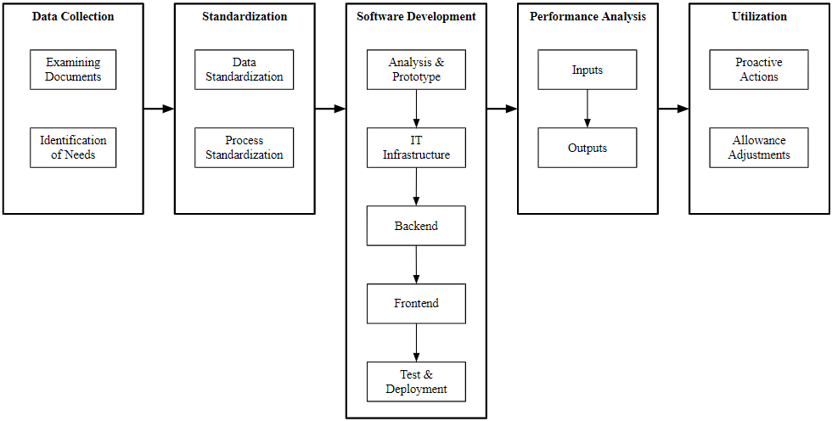
Figure 1. Methodology

Data Collection
The first step in developing the TMS was to collect data from the various institutions within the Ministry responsible for managing transportation projects. This data collection aimed to identify how these institutions were tracking the progress of their projects and to determine how this data could be standardised to create a more unified and efficient portfolio management system.
The data collection process involved a review of the file formats used by the different institutions to track project progress. These file formats vary widely, and some institutions even do not use formal systems to track progress. In addition, one-on-one interviews were conducted at project sites to gather information about the on-site project management processes.
The data collection process revealed several challenges hindering the effective management of transportation projects. These challenges and requirements included:
- The use of different file formats and project management systems by various institutions inhibits the ability to collect data from multiple sources in a standardised manner.
- The need for a centralised repository for project data underlines the need for a centralised repository.
- The need for a standardised approach to reporting to provide a comprehensive overview of the progress of projects across the portfolio.
The data collection process was an essential step in developing the TMS. The information gathered during this process helped identify the challenges hindering the effective management of transportation projects and define the requirements for the TMS.

Standardisation
It is of utmost importance to exercise caution and diligence in supervising earthworks and engineering structures such as viaducts and tunnels concerning the domain of transportation projects. By regularly recording, monitoring, and analysing the progress and financial state of these structures separately, one can facilitate accurate calculations for potential changes or time extensions. Also, these records will contribute to a valuable database of information for future endeavours. However, it is necessary to standardise the data and processes involved in these tasks to glean essential insights from this collected data. In order to ensure the sustainability of the standardised approaches, they need to be designed following each institution's needs while considering the Ministry's portfolio requirements. In this sense, standardisation studies can be examined under two main headings. The first is the standardisation of data, and the second is the standardisation of processes.

Data Standardisation
Data standardisation begins with creating a WBS that addresses projects in three sub-sectors: highway, railway, and urban rail systems. The breakdown structure has been prepared considering that all of the projects in the three sub-sectors naturally progress on a linear route.
Hence, it is necessary to determine a different approach from vertical projects to facilitate the construction site and progress tracking as well as establish the document management system in linearly progressing projects. While choosing floor and room-based work breakdown in vertical projects, a structural and route-based tracking methodology should be developed in linear progressive projects. In order to monitor the project in engineering structures detail, it is necessary to divide the projects to a level that will comply with the portfolio requirements of the Ministry. However, the activities resulting from this segmentation should also be manageable. If the breakdown is left at a very high level, it will not be possible to estimate physical progress, and if it is done in too much detail, it will not be able to address the whole portfolio and will not be traceable. The WBS created in this direction is given in Table 1. In this table, Level 1 represents the regions in the project, while Level 2 shows the activities that can be related to corresponding regions. Although the administrations and contractors who will use the WBS can create a particular, more detailed structure for their work, complying with this breakdown at a higher level will help all projects speak the same language at the portfolio level.

ID | Level 1 (Region/Structure Category) | Level 2 (Activity)
RE | Route Earthwork | Substructure
 |  | Under and Over Passes
 |  | Superstructure
 |  | Electromechanics
TN | Tunnel | Excavation
 |  | Covering
 |  | Superstructure
 |  | Electromechanics
VY | Viaduct | Substructure
 |  | Superstructure
 |  | Electromechanics
CC | Cut-and-Cover | Substructure
 |  | Superstructure
 |  | Electromechanics
GS | Grade-Separated Junctions | Substructure
 |  | Superstructure
 |  | Electromechanics
ST | Station | Substructure
 |  | Rough Construction
 |  | Finishing Works
 |  | Superstructure
 |  | Electromechanics

Table 1. Work Breakdown Structure
This work breakdown structure and methodology developed is called the "Linear Planning Requirements" of the Ministry. The Linear Planning Requirements define the work packages, deliverables, and milestones for all projects in the three sub-sectors. This ensures that all projects are tracked and managed consistently and that the data collected is comparable across projects.
The rules of LPRs while dividing the construction work on a regional basis are:
- Firstly, if any, grade-separated junctions, viaducts, tunnels, Cut-and-crossings, and stations are identified as a region by considering the starting and ending kilometres.
- Secondly, all parts between each region are identified as Route Earthworks.
- Thirdly, if any, Route Earthworks longer than 10 km are separated so that no region has a length of more than 10 km.
An illustration of an example regional division based on LPRs can be seen in Figure 2.
Figure 2. Regional Division Example based on LPRs

Process Standardisation
What is meant by the standardisation of processes is the determination of project management procedures that cover all processes that may affect the objectives of a project and the activities related to these processes, all workflows from the initiation of the project to its handover. The knowledge of experts and good practice examples were used in the determination process of procedures.
The standardised processes cover a wide range of activities, including:
- Project planning and scheduling
- Budgeting and financial management
- Risk management
- Quality management
- Communication and stakeholder management
- Documentation and reporting
Standardising processes ensure that all projects are managed consistently and that the data collected is comparable across projects. Also, the procedures contribute to the sustainability of TMS by incorporating the TMS in several workflows.

Software Development
The software development process for the TMS was complex and iterative. Commencing with a vital initial phase encompassed discerning the organisational requisites, entailing an in-depth comprehension of the Ministry's necessities and those of its stakeholders. Subsequently, an exploration of the prevailing software employed by institutions and the Ministry was undertaken to pinpoint any gaps in functionality or performance.
A visualisation of the interconnections between data entities in the system was generated via conceptual relationship mapping. Following this, prototypes were designed to test the system's functionality and user interface.
The next stage was the development of the software architecture. This involved outlining the components of the system and determining their intricate interactions. The TMS was structured as a three-tier architecture comprising a presentation, business logic, and data tier. The presentation layer manages the user interface and input using Node.js, a popular JavaScript framework for web applications. Meanwhile, the business logic layer, implemented with .Net Core and frequently utilised for enterprise applications, manages user input processing and workflow implementation. The responsibility of storing data in a relational database rests upon the data layer, which employs PostgreSQL, a powerful open-source database engine. The backend application follows the RESTful API paradigm, allowing seamless integration with other systems.
Once the software architecture was developed, the subsequent task was to install the application servers, databases, and software dependencies onto the Ministry's servers. The necessary VPN settings were also made for secure access to the system. Existing contracts and projects of the Ministry were employed as the data source to populate the database. This data has been transferred in a structured format to be utilised in the sophisticated architecture of the TMS.
The screens for entering data into the system were designed following the created WBS and LPRs. This ensures that the data entered into the system is accurate and consistent. With the use of the Geographical Information System (GIS), spatial data from necessary sources were stored and displayed. The outcomes of these analyses materialised as indicators presented on the dashboard screens. Next, performance analyses were conducted based on the entered data. The findings were presented as indicators on the dashboard screens.
The final step before the functionality and penetration tests to determine the application's security was the evaluation of the interface by the test team. Then, the software was ready to be distributed to the end users.
While creating and deploying the software, there were several key challenges of which:
- Data integration: The TMS had to integrate data from various sources. This was a complex and challenging task, as the data from different sources were often in different formats and had different levels of quality.
- Security: The TMS had to be designed with security in mind, as it would be used to manage sensitive data. This included access control mechanisms to protect the data from unauthorised access.
- Scalability: The TMS had to be designed to be scalable, as the Ministry expects to use it to manage a growing number of transportation projects.
Despite these challenges, the system was designed to be scalable and secure and was built using various open-source technologies. The next step is to conduct performance analyses on the construction contracts in the TMS system. These analyses will be used to identify any areas for improvement in the performance of the contracts and to ensure that the Ministry is getting the best value for money.

Performance Analysis
It may not be possible to handle the construction schedules of each contract in detail at the portfolio level. For this reason, contractors and engineers make data entries about the corresponding regions based on the construction schedule that has been zoned and prepared in line with LPRs. The period of these data entries was determined as each progress payment period in the standardised process flows. Thus, while the first entry is made on the first day of the project, users enter the data listed in Table 2 for each activity (Level 2) in each progress payment period.
Code | Item | Unit
TC | Estimated Total Cost of Project | $/€/₺
BC | Budgeted Cost | $/€/₺
AC | Actual Cost | $/€/₺
PS | Planned Start Date | -
PE | Planned End Date | -
AS | Actual Start Date | -
PG | Progress | %
CA | Critical Activity | (Y/N)
Table 2. Input Data for Performance Analysis
With these data entries, a summary planning screen is created in the admin dashboards, where only the regions with critical activity are highlighted, and the expected project completion date can be seen.
In addition to that, earned value analysis is made with the data provided. As a result of this analysis, expected deviations in the completion time of the work and the completion cost are predicted. Earned value analysis carried out within the scope of TMS consists of a process reached on a regional basis.

Earned Value Analysis
Earned Value Analysis (EVA) integrates cost, schedule, and technical performance, evaluating completed work's earned value, projecting performance and trends, functioning as an integrated, indirect monitoring method for complex time and cost dynamics (Kenley, 2003). The method is not only among the standards accepted by international institutes but is also frequently used in the monitoring of public projects (PMI, 2016). EVA is a tool that uses two key metrics to track the project's progress. The first of these two basic metrics is the Cost Performance Index (CPI). CPI evaluates the cost efficiency of a project. It provides insights into how effectively the actual costs align with the budgeted expenses for the work completed. A CPI value greater than 1 indicates that the project is under budget, signifying that the project is getting more value from the allocated budget. On the other hand, a CPI value of less than 1 suggests that the project is over budget, indicating that the costs of the work completed exceed the planned budget. Mathematically, CPI is calculated by dividing the Earned Value (EV) by the Actual Cost (AC), where the EV is calculated by multiplying the estimated total cost with the per cent complete.
In the context of the TMS, the formulation of CPI is as follows:
$$CPI=\frac{Earned Value (EV)}{Actual Value (AC)}=\frac{Progress \left(PG\right)\left[\%\right]×Estimated Total Cost (TC)}{Actual Cost \left(AC\right)[Progress Payment]}$$
The second of the metrics is the Schedule Performance Index (SPI). SPI assesses the timeliness and efficiency of a project. It gauges how well the project is adhering to the planned schedule based on the work completed. An SPI value greater than 1 signifies that the project is ahead of schedule, indicating that the work is being constructed faster than initially planned. Conversely, an SPI value of less than 1 indicates the project is behind schedule, implying that the work progress is slower than anticipated. SPI is calculated by dividing the Earned Value (EV) by the Planned Value (PV).
In the context of the TMS, the formulation of SPI is as follows:
$$SPI=\frac{Earned Value (EV)}{Planned Value (AC)}=\frac{Progress \left(PG\right)\left[\%\right]×Estimated Total Cost (TC)}{Budgeted Cost \left(BC\right)}$$
Note that the Budgeted Cost (BC) is calculated without reflecting the price differences to not cause miscalculations due to price fluctuations. All calculations are made based on contract prices.
Accordingly, CPI and SPI values are computed individually for every specified region of the contract using the cost and progress data entered into the system. The overall contract indices are calculated using weighted averages. While the overall contract index values are displayed on the executive dashboard, the regions below the critical thresholds in terms of CPI and SPI are also monitored in the background. In particular, the CPI and SPI values of the regions identified as critical in the construction schedule are displayed on the admin dashboard.

Limitations
The essential principle of this system is the zoning of progress payment forms based on the WBS. While the standardised construction processes indicate that progress payments must follow LPRs, it is impossible to calculate on a regional basis in projects where progress payments are not structured that way.
Secondly, progress data expressed as a percentage and collected regionally can be influenced significantly by subjective judgments of the people who enter the data. Inaccurate measuring of the physical progress of activities can cause deviations from realistic earned value calculations for construction projects (Marco & Narbaev, 2013).
Finally, carrying out the earned value analysis by employing cost values rather than person-hours may boost the influence of the CPI and SPI values of low-person-hour but large-cost activities on the overall contract performance. This may result in a biased interpretation of these indices.

Utilisation of Early Warning System
Within the TMS, admin dashboards are a pivotal tool, providing a complete overview of contract-related information, documents, reports, progress performance, planning outputs, and on-site project photographs. These dashboards offer ways to efficiently monitor and focus on the performance and planning tabs.
In the Performance tab, administrators are provided with a comprehensive understanding of physical and monetary project progression. The tab contains an earned value graph that shows past periods and forecasts future trajectories, flanked by Contract Performance Index (CPI) and Schedule Performance Index (SPI) values. A dynamic chart displays CPI and SPI values trending over different periods to further aid decision-making. The administrator can view the particular index values of the regions comprising these indices by selecting the overall CPI and SPI values. This approach allows for proactive intervention in problematic areas.

Cost Performance Index (CPI)
When an administrator reviews the overall CPI value of the project on the Performance tab and observes that it falls below the minimum threshold, three possible scenarios may have occurred.
Firstly, an advance payment may affect the CPI figures of the contract until the balance is established by deducting the amount from every progress payment. If no advance payment is made, the administrator may consider the following possibility.
In this instance, there is a potential for the total contract price to rise throughout the project, which has not yet been reflected in the total cost as a change in scope claim. The administrator can liaise with the corresponding project managers to investigate the change-in-scope status. Should the contractor be entitled to the claim, this will eventually correct the CPI value. The amount of potential scope change to be given to the contractor can be approximately calculated by the following formula using the CPI value. This insight is also shown in the performance tab in the dashboard. However, if no scope changes are expected, a low CPI value could imply one particular result.
$$Value of Scope Change=\frac{CPI}{Estimated Total Cost (TC)}$$
Although unlikely, it is possible that some items may be overbuilt in the site, even though they are not in the final project, due to some possible malfunctions in the proper monitoring of the productions made within the contract. While inconsistencies between the final project and the implementation process could potentially result in an undue condition, an actual change in scope would require approval for the implementation projects. This would increase the calculated total contract value, causing CPI to rise again to expected values. However, if faced with such situations, the management can increase the efficiency of the work carried out in the field, particularly by increasing the number of audits.
Furthermore, CPI values that fall below specific thresholds can indicate to project administrators that current budget allocations may not be sufficient for successful project completion. These limits may serve as an early warning mechanism. To comply with legal requirements, allowable scope changes in a contract may have defined limits, such as the 20% threshold adopted in Türkiye. Consequently, if a contract's CPI value falls below 0.8, it is possible that the project cannot be completed within the existing budget constraints. This prompts the administration to initiate preparations for a new additional tender covering tasks that remain undone or incomplete under the initial contract. This proactive approach empowers the administration to take timely and decisive action.

Schedule Performance Index (SPI)
When an administrator views the SPI value in the Performance tab and observes that it is below the minimum threshold, it is possible to deduce three situations.
Firstly, a scope change may have transpired, as referred to in the second situation for CPI, but has not been formally approved by project management.
Secondly, a contractor's legitimate claim for a time extension, similar to the scope change, could have remained unapproved. The potential time extension can be calculated using the following formula, similar to the one used for scope changes. If there is no entitlement to an extension, the last reason for the SPI being below the expected limit is lower than expected progress.
$$Extention of Time=\frac{SPI}{Total Duration of the Project}$$
Within this context, two main factors are responsible for obstructing percentage progress. The first factor involves "non-critical" delays that do not affect the ultimate project deadline. Such a delay may signify that the contractor is spending the total float of an activity not on the active critical path. The second reason can be attributed to the contractor performing a non-excusable delay in a critical activity. If the contractor is causing delays to a critical activity, management can ask the contractor to increase the pace of progress by adjusting factors such as crew numbers or shifts. Otherwise, the project owner may take action against the contractor to obtain damages. If the contractor expedites or compensates for the delay in this scenario, the SPI value will increase to acceptable values.
This analysis underscores the importance of considering regions on the critical path when SPI values do not meet expectations. Regions that are not on the critical path may not require an immediate response. The TMS provides insights and guides managerial action by approaching the contracts regionally, highlighting its crucial role in proactive and on-point decision-making.
The project dashboard's planning tab gives the administration control over the critical path. The planned start and end dates for regions identified as critical by the data providers are shown, along with the actual start date. Furthermore, CPI and SPI data are displayed for those regions. The discrepancy between the scheduled start dates of the regions on the critical path and the actual start dates serves as an additional indicator of the anticipated deviation of the final project completion date, in addition to the SPI projections.

CASE STUDY AND IMPLEMENTATION

Ankara – Sivas High-Speed Railway Project
The Ankara-Sivas High-Speed Train Project spans a total distance of 393km, linking Türkiye's capital, Ankara, and Sivas, one of the country's other major cities. The project was split into sections to ensure easy traceability and rapid construction and was awarded through multiple tenders. This case study focuses on the contract between the 45+440 - 74+100 kilometres, the last completed and most critical of these sections. Table 3 provides an overview of the key contract parameters.

Item | Value | Unit
Estimated Total Price | 574.405.800 | ₺
Contract Duration | 1080 | Days
Extended Contract Duration | 2405 | Days
Start Date | 11.07.2016 | -

Table 3. Parameters of the Case Study
Following a series of data entries to TMS, the contract's CPI and SPI values gradually deteriorated, reaching an all-time low in September 2022, as seen in Figure 3 and Figure 4. The administration promptly identified that the issues with CPI and SPI were caused by the T-15 Tunnel region, designated as the critical region, through the TMS admin dashboard.
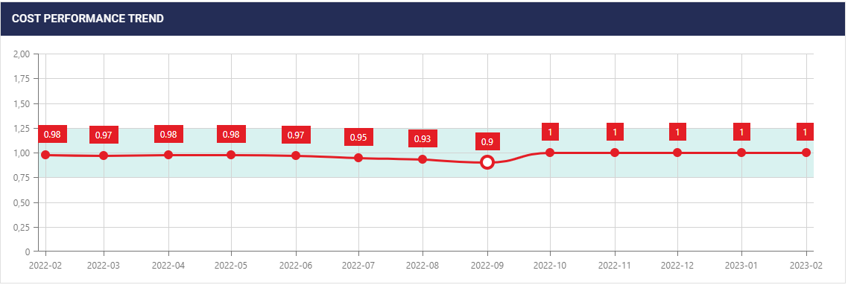
Figure 3. Change of CPI Values over Time
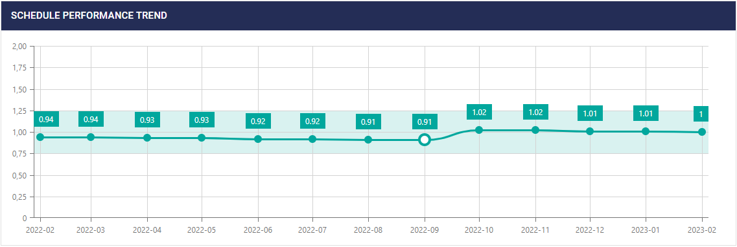
Figure 4. Change of SPI Values over Time
The T-15 Tunnel is a double-track, single-tube railway tunnel with a total length of 4,593 meters and a cross-sectional area of approximately 150 square meters. While the tunnel is longer than average, unforeseen ground conditions, which varied significantly from those anticipated in the original design based on the survey and engineering services data before the tender, led to slower-than-anticipated progress rates and dents. After these disruptions, the contractor re-designed the tunnel by making new in-situ borings and preparing the new design.
Following consultations with the project manager, the administration became aware of unforeseen ground-related challenges, which necessitated technical revisions to the tunnel's design. However, as stated by the management, the construction continued in parallel to avoid delays caused by disruptions in the ground survey, project design, and approval processes.
The contractor strategically maintained parallel construction to mitigate field-based stagnation while adhering to the allocated budget for the project. Subsequently, on-site production slowed down due to the factors mentioned above, causing the percentage progress to fall behind initial projections. This led to uncovered expenditures in the approved project, and though the estimated cost remained unadjusted, the contract price remained low. These two situations had a direct negative impact on the tunnel region and the contract CPI values.
These events caused temporary slowdowns in field production, sometimes halting progress and resulting in a significant shortfall in physical progress against plan. As the excavation phase of the T-15 tunnel was a critical activity, these delays naturally impacted the overall project completion date. As the employer is responsible for the ground conditions as per the contract, this situation can be classified as a excusable and compensable delay, leading to a legitimate claim for an extension of time by the contractor. Although there was a delay in the field operations during this process, the contractor reserved the right to claim additional time, provided that the employer was notified and work continued. Since the approved construction schedule was not revised during this process, the Budgeted Cost (BC) value became overestimated, resulting in a lower than actual SPI value.
After this monitoring process, the administration, who obtained the necessary information, intensified the field audits to reach the result quickly in this contract and closely followed the implementation projects of the contractor and the construction processes of these projects in the field. This approach resulted in progress rates higher than expected and minimised the need for time extension.
Moreover, acknowledging the significant deviation of the new cost estimate from the original project, an alternative approach was adopted. Rather than granting an expansion of the scope of the existing contract, specific contract components were seamlessly transferred, without additional cost, to contracts associated with different segments of the same project. This tactical action aided the project's delivery within the allocated budget. Thus, the CPI value is adjusted by a proportional increase in progress percentage rather than by an increment in the contract price. As a result, an increase in the progress percentage leads to a sudden jump in the earned value, bringing it closer to the planned value. This development can be observed in the earned value curve on the admin dashboard, shown in Figure 5.
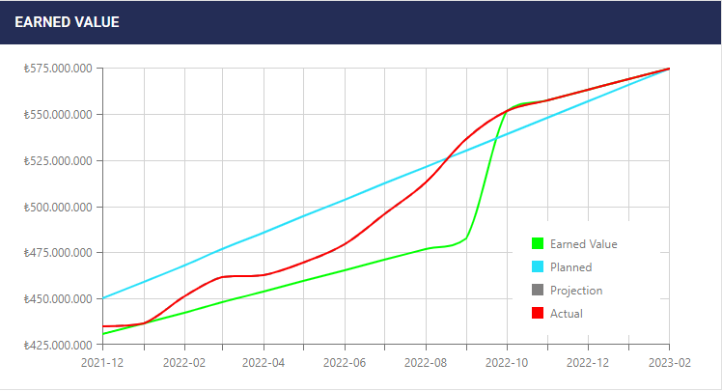
Figure 5. Graph of Earned Value Analysis

DISCUSSION AND CONCLUSION

Recap of Findings

Proactive Measures
Implementing the TMS has improved decision-making and proactive measures for managing transportation projects. The system utilises crucial performance metrics such as the CPI and SPI to provide early warnings and precautions. TMS enables administrators to take informed and timely actions, such as frequent site audits and early preparation of additional tenders, by promptly signalling deviations in project progression and financial condition. Project administrators can detect potential delays, overruns, and budgetary issues by closely monitoring the Critical Path Method (CPM) and employing CPI and SPI values in conjunction with TMS.

Allowance Adjustments
The TMS offers extensive surveillance for strategic allocation and adjustment of financial resources. A central repository of ongoing projects facilitates detailed assessment of budget allowances across diverse institutions under the Ministry. Administrators can track expenditure distribution efficiently, which allows for precise allocation of funds based on project needs. Integrating CPI values into financial planning facilitates flexible adjustments, aligning budget allocations with changing project conditions and estimated cost overruns. This combination of real-time data, performance metrics, and financial management optimises resource allocation and improves project outcomes.

Implications and Recommendations

Lessons Learned
The TMS improves transportation project management by utilising standardised data collection and integrated processes, resulting in efficient project oversight. The lesson learned from TMS implementations emphasises the significance of establishing a comprehensive WBS and implementing rigorous progress management methodologies, essential for improving project performance and informed decision-making.

Potential Future Improvements
Integrating digital twin technologies into the TMS framework could enhance real-time tracking and 3D coordination of construction projects. Combining BIM and GIS integration within the TMS could provide comprehensive visual insights, streamlining collaborative project management and decision-making processes.
Furthermore, the continuous inflow of data into the TMS lays the foundation for advanced artificial intelligence (AI) applications. By utilising the potential of AI, the system could be expanded to generate predictive models able to anticipate prospective project delays, cost fluctuations, and budget balancing scenarios. AI-driven recommendations, derived by analysing historical data and performance trends, could aid administrators in reaching well-informed decisions. These AI-generated insights could substantively enrich the general effectiveness and success rate of transportation projects.

Conclusion
A comprehensive digital management tool, like TMS, is vital for organisations such as the Ministry, which manages an extensive portfolio of projects, to keep pace with the demands of the current era. The implementation highlights the importance of comprehensive data integration, standardised processes, and real-time performance analysis. TMS handles complex transportation project management challenges, providing a resilient, proactive decision-making and resource allocation platform. The TMS provides a valuable example for future enhancements, enabling the industry to meet challenges with resilience and drive innovation.

REFERENCES
Berger, R. (2016). Digitization in the construction industry.
Easton, J. M. (2022). Digitalization and the Transport Industry – Are we Ready? 2022 IEEE International Conference on Big Data. IEEE.
Kenley, R. (2003). Managing through earned value. Financing Construction (s. 105-135). içinde New York: Spon Press.
Koeleman, J., Ribeirinho, M. J., Rockhill, D., Sjödin, E., & Strube, G. (2019). Decoding digital transformation in construction. McKinsey & Company.
Mallela , J., & Bhargava, A. (2021). Advancing BIM for Infrastructure - National Strategic Roadmap. U.S. Department of Transportation Federal Highway of Administration.
Marco, A. D., & Narbaev, T. (2013). Earned value-based performance monitoring of facility construction projects. Journal of Facilities Management, 69-80.
McKinsey&Company. (2020). The next normal in construction.
Pappas, I. O., Mikalef, P., Giannakos, M. N., Krogstie, J., & Lekakos, G. (2018). Big data and business analytics ecosystems: paving the way towards digital transformation and sustainable societies. Information Systems and e-Business Management(16), 479-491. https://doi.org/10.1007/s10257-018-0377-z
Parusheva, S. (2019). Digitalization and Digital Transformation in Construction - Benefits and Challenges. Information and Communication Technologies in Business and Education, (s. 126-134).
PMI. (2016). Earned Value Management. In Construction Extension to the PMBOK Guide (p. 72). Project Management Institute.
Winfield, M. (2020). Construction 4.0 and ISO 19650: A panacea for the digital. Proceedings of Institution of Civil Engineers: Management, (s. 175–181).

This limit can be increased up to 40% by the administration in some special cases. In this case, the minimum CPI that can be tolerated will be 0.6.
The term is used for a new tender that covers work required to be completed within a previous contract but cannot be completed due to unexpected circumstances.

